TOGETHER NEWS
Sunday 2nd August 2020

Welcome to our Twentieth ‘Together News’.

In Matthew 18:20, Jesus promises that 'Where two or three are gathered in my name, there am I among them.'

The truth is that wherever we meet together in Jesus name, he is with us. During lockdown, as things have eased, it's been lovely to hear that within the guidelines, folk have been meeting for Prayer, coffee, encouragement and to catch up. One thing that I have become more aware of is that Church is not what we do but what we are and this means that Church has been visible across the Benefice even when our parish Church buildings have been closed.

However, it has been the welcome practice since God began drawing people to himself, for them to congregate together to Worship and for mutual encouragement. Whether in the Old Testament Tabernacle, New Testament Temple or people's homes after Pentecost, God has been powerfully present. In Hebrews 10 v25 we are reminded to carry on meeting together for mutual encouragement. So, on August 9th we will begin to do just that, returning to the joyful practice of congregation together on Sundays (the day of Resurrection) to Worship God, listen to his word, open our hearts in Prayer and delight in greeting each other in the name of Jesus!

"What could be simpler?" you may ask!
A lot of work has gone into ensuring that we comply with Government and Church of England guidance in relation to meeting together and Kate has explained what is required of us if we are going to meet together. Please read the instructions clearly in this Newsletter and follow directions about booking.

Sadly, space is limited to 50 Worshippers at St Michael’s, 30 Worshippers at Christ Church and 30 Worshippers at All Saints. This means that booking is essential.

For some, gathering together in this way presents a real challenge, others will be pushing at the door but for most, there will be anxieties. I want to reassure you that the Church Wardens and those responsible for health and safety have worked hard to ensure your safety. However, if you have symptoms, then please stay at home.

But please remember that if you cannot be with us, you can still 'be church', speaking on the phone, meeting online, texting or emailing. Those who can, invite folk for a cuppa or a chat, go for a walk or even meet in the pub for a drink. It's all Church if our desire is to Worship God and encourage each other. And if it is Church then pull up another chair because Jesus wants to sit with you!

Thank you for your patience, Prayers and for every encouragement as we continue to keep faith alive and hope strong.

Moving forward with you with thankful hearts,
David, Ann and Clarrie
Revd. David, The Vicarage, 5 Forest Gardens, Lyndhurst SO43 7AF 07468 527820 / potterton.david@newforestparishes.com

Online booking

We are overjoyed to open our doors once more to gather together for Sunday Worship but remaining safe throughout is paramount to us.

Booking can be made on our website www.newforestparishes.com or on the phone for those without internet access - Kate, 07776 221663. Kate is responsible for taking bookings and would prefer those who are booking to go direct to our Parish website please, rather than call, as there are details requested to help us comply with the NHS Test and Trace.

In line with government guidance we are assisting the NHS with the Test and Trace service, by keeping an accurate temporary record of visitors to our Churches for 21 days (from the day of attending). You data will only be shared if requested by the NHS Test and Trace Service to help support the investigation of local outbreaks. If for any reason you are unable to attend a pre-booked Service, you will be removed from the list.
How to book online in 3 simple steps

We have made booking as simple as possible and it won’t take you longer than a few minutes. Places are limited, as mentioned in David’s letter so please don’t delay. Booking will close at 6pm, the evening before the Service or once fully booked (if before).

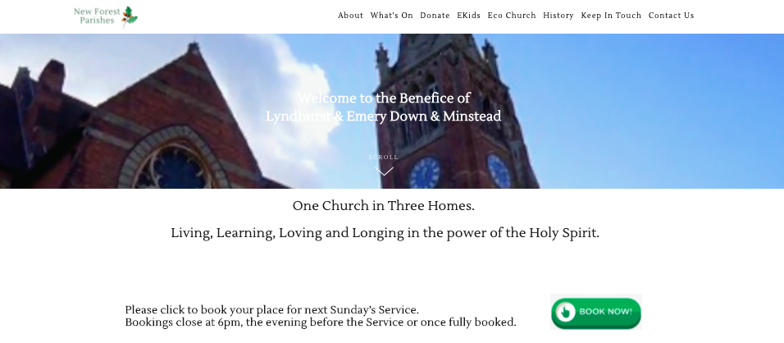
We want to ensure that everyone gets to attend a Sunday Service so if you attend one week, preference when booking will be given to anyone who has been unable to get a place, for the following week.
Step 1

Go to www.newforestparishes.com

Click BOOK NOW
from the homepage
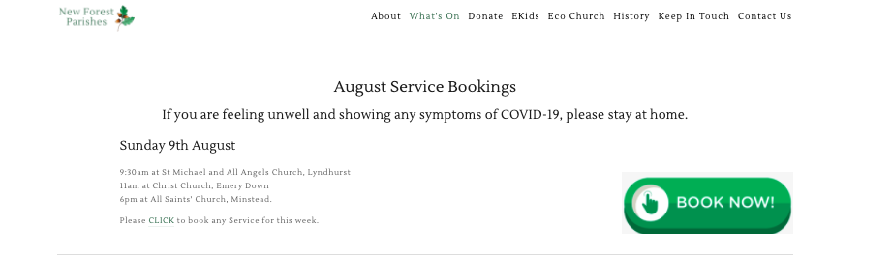
Step 2
Click BOOK NOW for the date
you’re booking for.
Any additional events will be
added here in due course.
Step 3
Please fill in the form carefully and click SUBMIT. You will receive an automatic email confirmation so you know we have received your booking.
Keeping Faith Alive and Hope Strong

Parish Church Opening Times for Private Prayer

Please see the table below for details of opening times. From the 9th August, Prayer times will be revised to accommodate the up and coming Sunday Worship and published in next week’s newsletter.

St Michael’s, Lyndhurst | Wednesday & Sunday | 8am – 10am
Christ Church, Emery Down | Tuesday & Saturday | 10am – 6pm
All Saints’, Minstead | Sunday | 9am – 11am

This Week’s Services

All LIVE services are accessed via Facebook. Where files are not too large, these will also be uploaded afterwards and be available via our website and YouTube.

This Sunday isn’t the last of our online services. We will be Streaming the 9:30am Sunday Worship from St Michael and All Angels weekly, so if you’re not able to get a space one week or you’re unable to attend, you can still ‘join’ us.

Facebook - https://www.facebook.com/benefice.newforest/

YouTube - https://www.youtube.com/channel/UCOOjetLI_-NZ7M3Kpy1tH8w/featured?view_as=subscriber

Website - https://www.newforestparishes.com/Worship

Sunday  2nd August | 10:30am | Together Worship | Pre-recorded, view on Facebook/YouTube. Links above.
Thursday  (Every week) | 9.30am | STILL Online Prayer Meeting | https://www.zoom.us/join  ID: 774 5029 4172  PW: still
Thursday | 8.30pm | Relax and Reflect  Music from Taiźe | LIVESTREAM via Facebook
Sunday  9th August | 9.30am | Sunday Worship | St Michael and All Angels,  Lyndhurst
Sunday  9th August | 11am | Sunday Worship | Christ Church, Emery Down
Sunday  9th August | 6pm | Sunday Worship | All Saints’ Church, Minstead

SPOTLIGHT

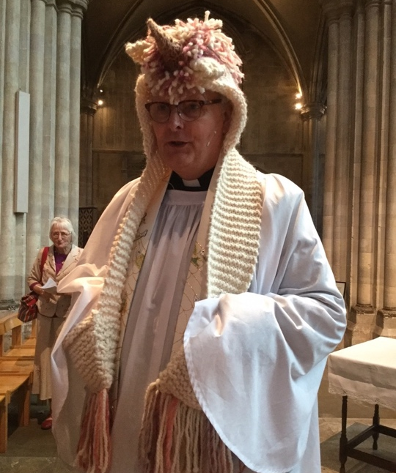
ON David Potterton,

a ‘secret unicorn’

What have you done for St Michael’s over the years? – Now that’s an interesting one! Ann and I arrived in Lyndhurst two years ago, almost to the date and so our contribution to the life of the church has been relatively brief compared to many in the parish.

It may be the case that not everyone is aware that David was asked by + Jonathan if he would allow him to present his name to the Benefice as ‘Bishop’s Presentation’. David had been discussing another parish in the Bournemouth Deanery prior to Lyndhurst being put on the table with a request from + Jonathan that we move our attention to the Benefice of Lyndhurst and Emery Down and Minstead. Ann and I made a couple of visits to each of the parish churches to reflect on what the Lord may be saying. It was whilst in St Michael’s that having spent some time in front of Leyton’s fresco that David pick an Alice in Wonderland postcard and wrote a message on it to + Jonathan simply saying, “The lamps are full, and the wicks are trimmed, and we are ready!” An interview was arranged at Minstead Trust and the rest they say is history. I remember getting an urgent telephone call from the Diocese asking for my mobile number as there had been an error in recording it and + Jonathan had called a lady somewhere in Scunthorpe offering her the post of Priest in Charge of the Benefice! I eventually got the call and without any hesitation said yes, after checking that he had the right number.

What made you want to help? – There was an overwhelming sense of opportunity. I had of course read the ‘carefully produced’, ‘professionally presented’ and ‘Diocesan edited’ ‘Parish Profile’ and was excited about what I interpreted as a desire to ‘move forward’ in ministry and mission. A willingness to be different, do differently and make a difference in the communities in which we served. I of course knew nothing about the past but believed that my passion for the community to be at the heart of the church was a good fit for the prayerful ambition of the Benefice. I was encouraged by the questioning from parish representatives on the interview panel who expressed a genuine desire to honour the past at the same time as being a church which spoke to the reality of people’s lives today.

I was sure that a ministry of Word and Spirit would be welcome and supported and so it was a joy to sign the piece of paper which invited me to serve Jesus Christ in the Benefice at the invitation and under the authority if the Bishop Tim. Of course, I wanted to help, but I only accepted the invitation on my understanding that we would help one another - and with God’s help would witness God’s Kingdom come afresh across the Benefice.

I have to say that looking at the photographs of all who were included in the Parish Profile (Church Wardens, Members of the PCC etc.) at how youthful everyone looked. On arrival I wondered how many had been selective in which photographs of themselves they were happy to include. It seemed to me that with a few months of arriving pretty much everyone had aged significantly!!

What do you enjoy most about it? – There is no doubt in my mind that the greatest joy for me in being the PiC here is the opportunity I have to engage with folk in the community. Building relationships with those for whom church has never been part of their life or experience is a real joy. Making God present wherever possible my greatest joy. And as I reflect on Jesus’s ministry, much of his work was done on the pavement on the way to somewhere. I regret that the administrative demands of leading three parishes with the number of meetings/papers/hours required to keep the wheels turning keep me from being where I need to be. I did so enjoy being available in the New Forest Inn and the Trusty Servant early on in my ministry here (with some wonderful conversations) but sadly, this has fallen by the wayside because other demands. I am convinced that if we are going to succeed in the Mission of Jesus (WHICH WE MUST) then we need to think carefully and bravely about how the Benefice is administered – a process that is not anticipating closing of churches but will increase capacity for ministry and mission in each of them. Now that is something that will bring even greater joy as we make the kind of changes that will prevent concerns about extinction and provide confidence of expansion.

What do you do when you’re not helping out at church? – I love my pianos – my clarinet and my Ukulele – all of which have been used greatly during lockdown. I have played the piano so much that I now have hand splints to help with the pain in my hands caused, possibly, by overplaying! Along with making music, I have managed to plant some fruit trees and build a raised bed which required 5 tons of topsoil to fill it! There is something wonderfully relaxing about ‘pottering’ in the late evening in the garden. This is a new and welcome discovery. However, this has turned more into a policing event to ensure that Clarrie hasn’t so lovingly dug up what we have so lovingly put in!!

Is there anything you have enjoyed during Lockdown? – The truth is that the commitment to keep faith alive and hope strong, principally through recording Priest in a PANdemic (humorously shortened to ‘P in a Pan’ which sounds more like the instruction one receives from a nurse in hospital than a project to keep faith alive and hope strong!!). When we began to live stream Sunday Services (now recorded) and the antics of a purple puppet called Denzil has been so exciting but at times equally exhausting. I had to learn the technology, learn how to use the kit, learn to edit the videos, learn, learn, learn and then learn to live with very real anxieties about the technical quality of what we were putting out there. Problems with internet speeds for uploading, software crashes late into the night and the realisation that is probably not that good for anyone to sit for that long in front of a computer screen bringing all the components together to produce the recordings each Sunday. But for all that, hearing that someone who is isolated loved watching, a prayer group in Vancouver were so grateful, a lady in Italy was thrilled to re-connect with the parish church she and her husband left many years ago and all the effort was keeping folk connected to one another – a feeling of still being part of their ‘church’.

I have enjoyed reflecting on my own Christian journey, looking back to those early years when everything was so new. Finding old records with many of the worship songs I used to sing has been just lovely. Can anyone remember Jimmy and Carol Owens? I’m looking for their ‘Come Together’ Album which was so important to me when I first became a Christian and experienced the baptism of the Holy Spirit back in the early 1970’s!

I’ve enjoyed walking down the High Street and hearing shouts of “Hello Revd. David’ from kids who know me from school.” It has been an enjoyable but at times exhausting, an exhaustion that has made it difficult at times to pray, to prepare ministry and to be the ‘life and soul’ of the parish for everyone who I meet.

I’ve enjoyed catching up with folk I’ve not spoken to foe many years who have ‘found me’ via our Facebook presence.

Personally, for me, the greatest joy was that moment when we saw our children and grandchildren again. Joyous doesn’t cover it.

What one thing would you like to see happen, in light of the changes from Lockdown? – A re-discovery of the importance of ‘small things’. Small groups meeting, praying, and growing together. Small acts of kindness and generosity which have become so precious in our communities, Small projects which bring people together with a common purpose. For too long the church has been conditioned to think ‘Big’ – and whilst we aspire to be a larger church - to discover and reflect a larger faith, a greater generosity in use of our time, money and gifts etc. its is worth reflecting again in the parable of the mustard seed. Success in making Jesus known and seeing more people coming to faith in Him and more people telling stories of transformed lives will happen if we give attention to the small things. The parable of the Mustard seed (Matthew 13) is a powerful reminder of the value, significance and power of small things. I was pleased to receive this piece of advice recently: “don’t over-estimate what you can achieve in two years and underestimate what you can achieve in five”. Good advice. I’m sure that everyone is aware that I ‘dream big’ but I have grown to appreciate that ‘small things’ as necessary as we grow towards bigger things. Attempting great things to God is not a reference to size or cost but significance. Holding out a hand to support the weak will not be forgotten but perhaps spending hours and hours raising money to replace the church floor will be. I’m still working this through!

So, I hope that we can remain generous in our thanks and encouragement, be willing to help our neighbour with whatever they may need, be ready to make the difference by giving a little of our time and a brief word of encouragement. If we all do this, then our reach for the gospel becomes wider and the impact of the gospel becomes greater. It seems strange that I am suggesting ‘less’ having spent two years pressing for ‘more’, but perhaps we have all learned that ‘little and often’ is more effective than ‘much very occasionally’ can ever be. You may need to remind me of this nugget of wisdom!!

I’d also like to be able to lead a service as ‘Eunice the Unicorn’, my secret alter ego!

Your Opportunities to Serve

Thank you to any of those who have contacted us over the last week. There are many opportunities to support the Benefice and we are currently looking for volunteers to support;

- Compline, recording from the comfort of their own home.
- Readings for Sundays, reading Lessons and Intersessions for Sunday Services.
- Opening of our Churches, for Private Prayer and supporting Services once they open.

Please contact Kate Donohoe if you’re able to help communications@newforestparishes.com

Your Gifts are Keeping Faith Alive and Hope Strong in the Benefice and beyond!

Weekly Offering - If you are not giving regularly it would be a great help to the PCC if you were able to do so. Please speak to your PCC Treasurer or David. If you have access to the internet, you can also donate to your Parish Church via our website www.newforestparishes.com click on ‘Donate’.

Easy Fundraising - Visit www.easyfundraising.org.uk and register to donate without costing you anything! Simply find your ‘cause’, searching by name and then carry on with your shop.

Text to Donate - St Michael’s - text the words STMICHAELS to 70085 for a one off donation of £5.00. All Saint’s - text the words AllSaints to the number 70085 for a one-off donation of £5.00. If you wish to donate more or less than £5 to either, substitute 5 with any amount between 1 and 20. Christ Church - text the words XChurch 3 to the number 70085 for an instant donation of £3.00 and a monthly, reoccurring payment will be made of £3 to Christ Church. If you wish to donate more or less than £3, substitute 3 with any amount between 1 and 20. You can cancel the reoccurring payments at any time.

NEW Parish Giving Scheme Telephone Service
Available weekdays from 9am to 5pm. Calls will take less than 15 minutes and you will receive written confirmation afterwards to confirm the details. At anytime you can call the service to make amendments to your direct debit. Call: 0333 002 1271

Baptisms, Weddings and Funerals are now permitted in our parish Churches but with restrictions. Suzanne has been in regular contact with wedding couples, most of whom have rescheduled their ceremonies for either later this year or into 2021.

VJ Day Commemoration Saturday 15th August, 11am at Christ Church. This will be a Benefice Service in the Churchyard. More details to follow.

Useful Information

SAY IT - PRAY IT!!

If you are concerned, anxious or troubled in anyway, you can text your Prayer to our ‘Say it Pray it’ number and we will pray for you immediately. No conversation or call back, just a simple text for you to share matters for Prayer! Why not give it a go this week?
WANTED: PRAY-ERS.

We need a team of ‘pray-ers’ across the Benefice who will carry the Prayer phone for a week (Sunday – Sat). Their (your) ministry will be to simply ‘pray the Prayers’ that are sent via text to the phone, either the moment they are received or as soon possible. You do need to be living where you have a good mobile phone signal! Let David know if you would like to share in this ministry. It just might be the thing that God is calling you to do and what a blessing you will be and receive!

Thank you for providing your contact details - We now have quite a comprehensive database which is a great help, especially for circulating Together News! If you or if you know someone who would like to be on our mailing list for the latest Newsletters, please email their details to Suzanne at benefice@newforestparishes.com.

Lay Pastors - If you know any member of the Benefice who would welcome a phone call and a chat, please let Peggy and Peter Nicholls know on 023 8028 2378.

Do you need any help at the moment, whilst in isolation - FOR HELP, CALL 02380 284 426.

Daily Hope - FREE PHONE Line of hymns, reflections and Prayers - 0800 804 8044

The Good Grief Trust - Coronavirus Bereavement Advice

COVID-19 NATIONAL NHS BEREAVEMENT HELPLINE - 8am - 8pm 0800 2600 400
A new Bereavement Helpline has been introduced by the NHS to support bereaved families during the Coronavirus outbreak. The new helpline is not a counselling service but will be available to offer support, guidance and advice on dealing with grief and loss.
The helpline will be staffed by NHS Blood and Transplant registered nurses who are highly skilled and experienced in working with bereaved people.

